**Purpose of the document / Guidelines for preparation of On-Line help document**

The purpose of this document is to create an online help document for OSRMT users.

Once the document is ready, we will enable it under “OSRMT’ help in the application as shown below

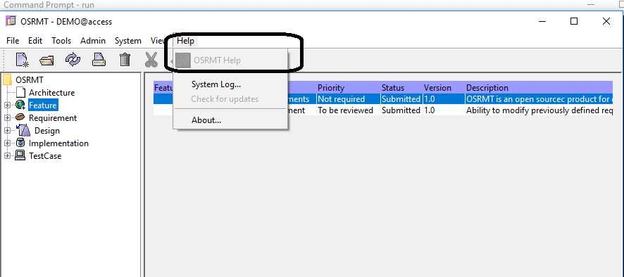

We need to prepare this document with a view that the user may not have any access to other documentation or help. This should cover all aspects of the application so that it will help use the system fully.

We also need to create a search index. We need to create the document in such a way that the respective sections can be displayed in the relevant screen

Please use content from the FAQ document and user guide as necessary.

Please see a general structure below.

1. **OSRMT**

Open Source Requirements Management Tool (OSRMT) is a highly configurable, free open source solution for defining and managing Requirements for software development. This is an easy to install and easy to use solution with capabilities to document all aspects of software development life cycle (SDLC).

This solution was initially built in 2006. The current version (Version 1.6) was released in Feb 2019 at GitHub. This can be accessed through [**https://github.com/osrmt/osrmt**](https://github.com/osrmt/osrmt)

**Operating systems supported**

OSRMT is available on Windows, Linux and Mac OS.

**Databases Supported**

OSRMT works on MS access, My SQL, Oracle Express, PostgreSQL

1. **Why OSRMT is important?**

Poorly managed requirements lead to many software projects failing. That’s why it’s important to have a systematic way of documenting, analyzing, and prioritizing requirements.

OSRMT helps is a powerful tool that helps to resolve this problem.

1. **Community**

We are building an active community of volunteers and users to support one another as we develop a great open source requirements management tool.

Programmers, system analysts, DBA’s, technical writers, UI/UX designers, solution testers, business analysts and anyone who is interested in supporting an expanding open source community are all welcome to join the OSRMT community.

1. **Support**

There are very comprehensive documentation available for implementation and system usage. That includes, Installation guide, User guide and Developer guide. All these documents are available in GitHub.

For any technical support please write to [osrmt2019@gmail.com](mailto:osrmt2019@gmail.com)

**PRODUCT FUNCTIONALITY**

1. **Creation of New Products**

The first step is to create a new project is to create a ***“New Product”*** to store all requirements and other artifacts.

Create a new product from the menu item File 🡪 New Product

The product name that is entered above will be displayed throughout the application and standard reports.

1. **Artifact Tree**

Artifacts can be defined by the administrator. The artifacts that are available as base line are ***Features, Requirements, Design Modules, Implementations and Test Cases***

The name of the artifact can be customized by the Administrator. The default list is shown below. Artifacts can be created under each of these artifact types.

1. **Creation of artifacts**

To create a new artifact, choose ***New Artifact*** option under ***System*** *tab.*

To create an artifact of a specified type, select the artifact and click on the ***New button***.

For example, to create a New Feature, Choose ***New Feature*** from Menu bar and enter the relevant data in the screen and save the record to create a child record under Feature artifact

1. **Managing Features**

Feature is the topline functionality of a Requirement Management toll (RMT) ,wherein the key features of the software is defined.

The key attributes of this functionality are

* Feature title
* Detailed description of the feature
* Priority or criticality of the feature
* Dependency on any other feature or functionality

System allows to define any number of features. It is possible to add /remove /update features at all stages of the software development. It is also possible to trace or track the changes made to a feature during the life cycle of the project.

1. **Managing Requirements**

Once the features are defined, the detailed requirements need to be defined

The key attributes of this functionality are

* Feature title
* Detailed description of the requirement
* Priority or criticality of the requirement
* Dependency on any other requirement or functionality
* Complexity ( medium, high, low)
* Category ( Business requirement, data requirement, system requirement etc)

It is possible to define the background/ Context of this requirement.

It is also possible to define a use case for the requirement.

System allows to define any number of requirements. It is possible to add /remove/update requirement at all stages of the software development. It is also possible to trace or track the changes made to a requirement during the life cycle of the project.

1. **Managing design**

RMT offers the functionality to document the design considerations.

The key attributes of this functionality are

* Design title
* Detailed description of the design consideration
* Priority or criticality of the design
* Dependency on any other component.
* Category of design

1. **Managing Implementation**

This functionality provides the place holder for all implementation related activities.

It is possible to either upload the source code itself here or to keep the location and file name for the source code.

It is possible to create and keep details of multiple versions here.

1. **Managing Test cases**

This is a very powerful feature that enables creation of test cases against every requirement.

Key attributes of this functionality are

* Title of the test case
* Purpose of the test case
* Pre requisites or dependency on this test case
* Steps
* Test Data
* Expected outcome
* Notes or comments on test results.

The provision to keep history enables the user to compare the results against every previous test cycles.

1. **User Management**

This is a multi-user / multi-level access controlled system.

The super user has access to create users and assign responsibilities.

All standard features of a use management module (Reset password, enable/disable users, change access level, trace history of changes etc ) are all available here.

1. **Reports**

RMT has a very good reporting module.

It is possible to define SQL report and XML reports.

To generate SQL report, please define the following

* Report Name
* Report Directory
* Parameters for the report
* Output file name
* The SQL statements

To generate XML report, please define the following

* Select Script
* Sort Script
* Field script
* Image script
* The SQL statements
* The Query

There are also system predefined reports that are available. The output of these reports are available in **pdf** or HTML format.

1. **Traceability**

System has the capability to trace activity between any stage or all stages. For example, it is possible to trace from “Feature” to “Design”. It is also possible to trace by Trace type.

It is also possible to trace the impact of changes made.

1. **Filter**

It is possible to filter the requirements and stages based on the following criteria

* Version
* Status
* Category
* Priority

For example, you can use this feature when you want to see all “open” Items or when you want to see all “High” priority items.

1. **Error Messages**

System has built-in error messages that will provide clarity on any problem or on the corrective steps that need to be taken.

1. **Change Controls**

All software development project goes through change controls and OSRMT provides a powerful feature to record, track and manage all change controls.

This is available under “View” Menu tab..

It is possible to view change requests in any of the following category

* All change requests
* Open change requests
* Change requests pertaining to the logged in user.

The key attributes of change control are

* Name of Change Request ( CR)
* Description of CR
* Priority
* External reference number
* Severity
* Assigned user